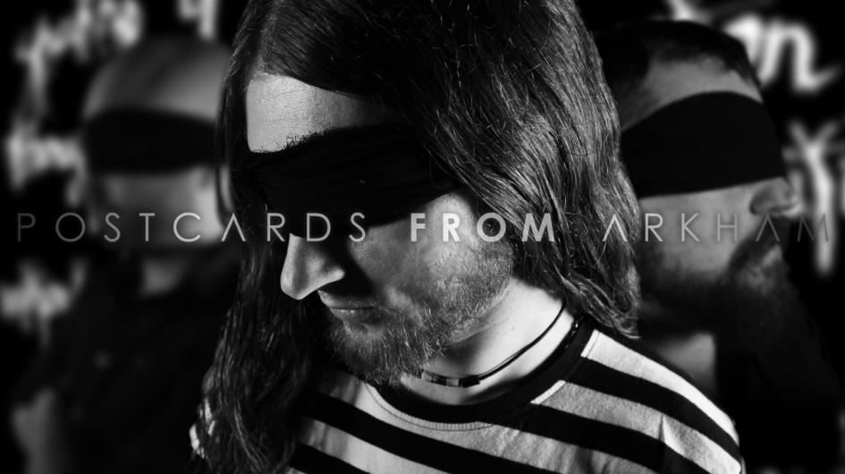
artist: POSTCARDS FROM ARKHAM
formed in: 2012
genre: Atmospheric Post-Rock, Post Black, Acoustic Folk
country: CZECH REPUBLIC

Discography:
2019 - ØAKVYL
2018 – SPIRIT (acoustic album)
2017 - MANTA
2015 - ÆØN5
2013 - You Know There's Something (Single. Clip)
2012 – OCEANIZE

POSTCARDS FROM ARKHAM career highlights:
2012
- album OCEANIZE (the 5th Newcomer of the year Britva Awards 2012)
2014
- festival Czech Death Fest (with SEPTICFLESH, LOCK UP ...)
2015
- album AEON5 (The 5th best album in Britva Awards 2015)
- music video Aeon Echoes (The 2nd best music video in Britva Awards 2015)
- festival Brutal Assault 2015 (with MASTODON, KATATONIA ... )
- tour Dreamscapes 2015
2016
- support for ANTIMATTER (UK)
- support for MORTIIS (NOR)
- festival Czech Death Fest (with DODHEIMSGARD, THE GREAT OLD ONES...)
- tour Octodance 2016
2017
- album MANTA (The 5th best album in Britva Awards 2017)
- music video The Kvlt Ov Dream (The 2nd best music video in Britva Awards 2017)
- festival Brutal Assault 2017 (with EMPEROR, OPETH ...)
- festival Castle Party 2017 (with MY DYING BRIDE (UK))
- festival Horizons Fest (with TIDES FROM NEBULA, THE RED PAINTINGS)
- support for JINJER (UKR)
- support for OBSCURE SPHINX (PL)
- tour Acoustic Busking Ritual (acoustic tour)
- tour Manta Over Poland (with AU DESSUS (LIT))
2018
- acoustic album SPIRIT (The 3rd best compilation album in Britva Awards 2018)
- music video Leviathan (The 6th best music video in Britva Awards 2018)
- festival Czech Death Fest (with ROTTING CHRIST, MASTERS HAMMER)
- festival Prog In Park (with ANATHEMA, IHSAHN, LEPROUS)
- tour Manta & Dissonance 2018
2019
- album ØAKVYL (The 2nd best Crossover album in Britva Awards 2019)
- music video Erich Zann Syndrome (The 2nd best music video in Britva Awards 2019)
- tour A Mile Beneath The Ocean
- tour ØAKVYL Live Sessions

contact: postcardsfromarkham@gmail.com
facebook: www.facebook.com/PostcardsFromArkham
bandcamp: postcardsfromarkham.bandcamp.com/
official page: WWW.POSTCARDSFROMARKHAM.COM

video:
Erich Zann Syndrome: https://youtu.be/4BbpVWRttDg
The Kvlt Ov Dream: https://youtu.be/SRDXGXoL7o4
One World Is Not Enough: https://youtu.be/a0-Jqu2bFPM
AEON ECHOES : https://www.youtube.com/watch?v=eiDxPDVx7WU
AE0N5 album sampler: https://www.youtube.com/watch?v=lS_JgL_q87M
Pendulum cover : https://www.youtube.com/watch?v=ckUvv8vlO2M
You know There’s Something: https://www.youtube.com/watch?v=WVIhBptpFKI

There are many bands that draw inspiration from the mysterious, dreamlike, simply weird world of the American novelist H. P.Lovecraft. One such band can be found also on the Czech scene, though you would look for it in vein within the metal genre. What we refer to is POSTCARDS FROM ARKHAM, a post-rock project, whose mastermind is Marek “Frodys” Pytlik, who arose from the iconic North Moravian doom act DISSOLVING OF PRODIGY, as well as from the melodic death metal band AWRIZIS.

Live highlights: Brutal Assault 2015 and 2017, ANTIMATTER – support 2016, MORTIIS – support 2016, OBSCURE SPHINX support 2017, JINJER – support 2017, Czech Death Fest 2014,2016,2018 Dreamscapes Tour 2015, Octodance Tour 2016, Busking Tour 2017, Manta Over Poland 2017, Castleparty 2017, Prog in Park 2017.

